See the Sights and Feed Your Soul:

Mexico City 2018
Saturday June 16 – Friday June 22
With optional Frida and Diego tour Saturday June 23

Immerse yourself in the ancient, colonial, and modern history, art and architecture of Mexico City

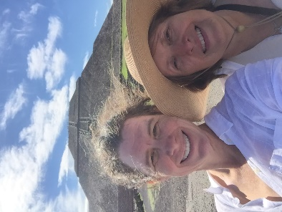
Trip Highlights
- Stay in the Historic Centre of Mexico City, a UNESCO World Heritage site
- Climb the pyramids of Teotihuacan and then submerge yourself in the ancient murals
- Board a brightly decorated boat and explore the floating gardens of Xochimilco
- Find yourself at the center, and the heart, of Mexico City-- the Zocalo
- Immerse yourself in the riches of the Templo Mayor
- Experience a temazcal (sweat bath)
- Tour the Museum of Anthropology with your expert guides and then enjoy the awe inspiring Danza de los Voladores de Papantla
- Bring the past into the present through a ceremony with a local curandera
- Bring your prayers to the Basilica de la Virgen de Guadalupe and Tepeyac, original worship site of Tonantzin Plunge into the chaos and beauty of the Mercado Jamaica, the “Flower Market”
- Dine on world-famous entrees and finish dinner with a steaming cup of hot chocolate at Café de Tacuba, right around the corner from our hotel
Tour: $1499* Tour includes 7 nights lodging double occupancy, all in-country transportation, entrance fees, and guided tours. Includes transportation to/from Mexico City International Airport (MEX). Does not include meals, gratuities, airfare.
Optional Frida and Diego Tour: $200* After a late breakfast, we board the bus for a short ride to San Angel, Plaza
de San Jacinto for the art and craft fair, Sabado Bazar. After perusing the many stalls of beautiful jewelry, pottery, paintings and art, we will meet for lunch in the Plaza de San Jacinto at the Fonda San Angel. After lunch, we board the bus for the short drive to Casa de Frida Kahlo. If time permits, we will end the tour at Anahuac, a museum of pre-Columbian art designed and curated by Diego Rivera. Frida and Diego Tour includes 1-night lodging double occupancy, all in-country transportation, entrance fees, guided tours. Does not include meals, gratuities, airfare or transportation to the Mexico City International Airport (MEX).

Why Choose Sacred Tours of Mexico? About your guides, Anne Key and Veronica Iglesias

RESERVE YOUR SPACE TODAY for $100!

Questions? Pay over Phone? Information on payment plan? Want single occupancy?

Call Anne 505-225-2142 or email anne@goddess-ink.com. www.sacredtoursofmexico.com
Physical Requirements: To fully participate on this trip, you should be able to walk 4 city blocks with minimal effort. At Xochimilco, you will need to be able to get in and out of a boat. To reach the chapel on the top of Tepeyac at the Basilica de Guadalupe, there are 100+ stairs. If you want to climb to the top of the pyramids at Teotihuacan, you will need to be able to climb 248 very steep steps. To fully see Teotihuacan, you will need to walk 1-2 miles total. Participants are always welcome to rest and wait for the group to finish any walking tour. To participate in the temazcal, you must be able to tolerate 100-120 degree temperatures in a
closed space. You are always welcome to leave the ritual if you are uncomfortable.

