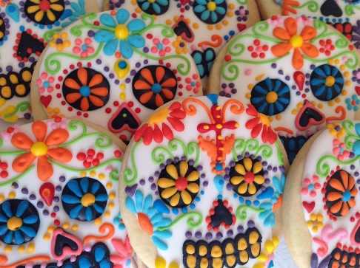
Dia de los Muertos

Xalapa, Veracruz
October 26- November 1 2018
optional excursion to Mexico City November 2-3

Immerse yourself in the indigenous tradition of Dia de los Muertos,

and find your own connection to your ancestors

Trip Highlights:
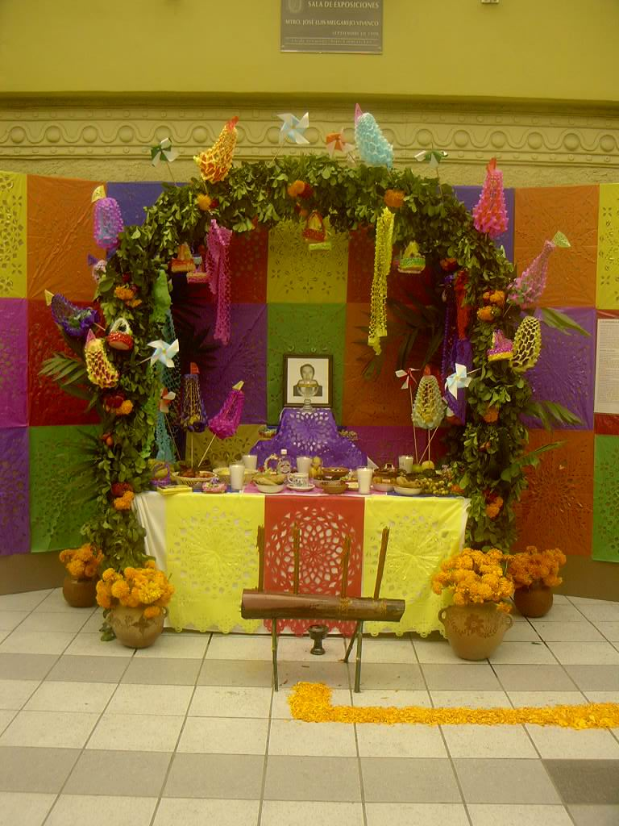
- See Day of the Dead altars from cultures across the state of Veracruz and attend a meet-and-great with anthropologists from the University of Veracruz that will explain local customs
- Experience Day of the Dead ceremonies at a local cemetery
- Visit the Museum of Anthropology in Xalapa, where you will see the famed giant Olmec heads as well as hundreds of other works of pre-Hispanic are
- Tour the Pyramids of El Tajin, a UNESCO World Heritage Site
- Shop in the vanilla markets of Papantla, the home of vanilla in Mexico
- See the Danza de los Voladores, an ancient Mesoamerican ceremony
- Participate in the Mictlan Festival Cultural, including parades, dances, outdoor altars
Tour: $1499*
Tour includes 7 nights lodging double occupancy, all in-country transportation, entrance fees, and guided tours. Includes transportation to/from Veracruz International Airport (VER).
Optional 2-day tour of Mexico City: $300* (Museum of Anthropology, Templo Mayor, Frida Kahlo Museum and much more). Tour includes 2 nights lodging, transportation within Mexico City, entrance fees, and guided tours. Does not include meals, gratuities, airfare from Veracruz (VER) to Mexico City (MEX).
*Plus tax for NM residents
Why Choose Sacred Tours of Mexico? About your guides, Anne Key and Veronica Iglesias

RESERVE YOUR SPACE TODAY for $100!

Questions? Pay over Phone? Information on payment plan? Want single occupancy? Call Anne 505-225-2142 or email anne@goddess-ink.com www.sacredtoursofmexico.com

Physical Requirements: To fully participate on this trip, you should be able to walk 4 city blocks with minimal effort. Participants are always welcome to rest and wait for the group to finish any walking tour.

